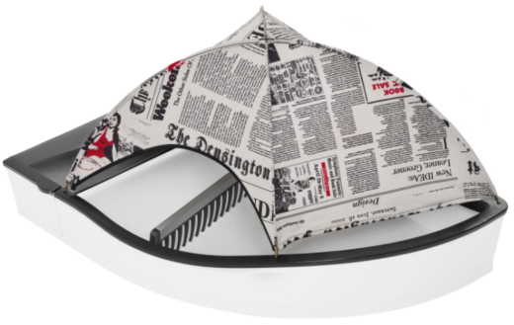 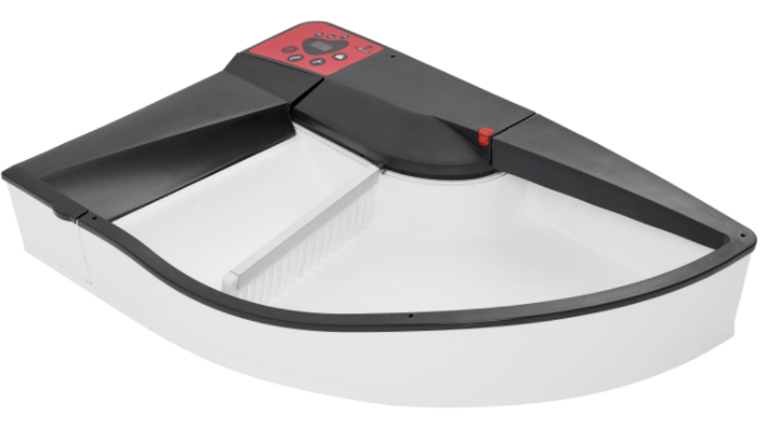

|  |  |  |  |  |  |  |  |
| --- | --- | --- | --- | --- | --- | --- | --- |
| **Produkt** | Kat. | Cena | upust | Cena klienta | Ilość | Wartość | Komentarz |
| **Smart Kitty** | ??Tu wpisz z tabeli | 450 | 50 | 400 | 1 | 450 |  |
| **Soft Tent** | Newspaper | 120/100 | - | 50 | 1 | 50 | Dowolny bamiot |
| **Rakes** | ?? | - | - | - | 1 | - | Free |
| **Panel** | ?? | - | - | - | 1 | - | Free |
| **Additional Boxes (20 pcs )** |  | 40 | - | - | 1 | - |  |
| **Transport** | PL | nd |  | nd | 1 | nd |  |
| **Total** |  |  |  |  |  | **450** | PLN (brutto) |

|  |  |  |  |
| --- | --- | --- | --- |
| Imie Nazwisko |  | | |
| **Forma płatności :** | Przedpłata | status: | **50 pln ( zapłacone) .** |
| **Data dostawy** | 20.05.2017 | | |
| Data for payment | Flying Fish Stasz I Kiełkowski S.J.  Tytułem: **Zamówienie nr../2017**  **Lub jeśli qnc tp pay {al.** | | |
| Nomer Konta | 50 1140 2017 0000 4702 1133 0463 | | |
| Serial Number (S/N) | 47 | | |
| Adress e –mail |  | | |
| Delivery adress | *Please fill it* | | |
| Telefon |  | | |

WYBRAŁEŚ WPISZ “1” you want just fill „1”

|  |  |  |  |  |  |  |  |  |  |  |  |  |  |  |  |  |  |  |  |  |  |  |  |  |  |  |  |  |  |  |  |  |  |  |  |
| --- | --- | --- | --- | --- | --- | --- | --- | --- | --- | --- | --- | --- | --- | --- | --- | --- | --- | --- | --- | --- | --- | --- | --- | --- | --- | --- | --- | --- | --- | --- | --- | --- | --- | --- | --- |
| SMART KITTY | | | | | | | | | | | | | | | | | | | | | | | | | | | | | | | | | | | |
| White&Black | | | | *?* | | White | | | | | | ? | | | | Black | | | | | ? | | | Black&White | | | | | | | ? | | | | |
|  | | | | | |  | | | | | | | | | |  | | | | | | | |  | | | | | | | | | | | |
| 450 PLN | | | | | | 450 PLN | | | | | | | | | | 450 PLN | | | | | | | | 450 PLN | | | | | | | | | | | |
| RAKES 18&16 | | | | | | | | | | | | | | | | | | | | | | | | | | | | | | | | | | | |
| Black | | | | | ? | White | | | | | ? | | | | | Red | | | | | | ? | | Green | | | | | | ? | | | | | |
|  | | | | | |  | | | | | | | | | |  | | | | | | | |  | | | | | | | | | | | |
| Panels | | | | | | | | | | | | | | | | | | | | | | | | | | | | | | | | | | | |
| Black | ? | | Red | | | | | | ? | Blue | | | ? | | | | Pink | ? | | | | | Green | | | | | ? | Grey | | | | ? | | |
| **C:\Users\Emilka\Desktop\Panel_Black_mm_lite_.jpg** | | |  | | | | | | | **C:\Users\Emilka\Desktop\Panel_BlueYellow_mm_L_lite_.jpg** | | | | | | | **C:\Users\Emilka\Desktop\Panel_Green_mm_L_lite_.jpgC:\Users\Emilka\Desktop\Panel_Pink_mm_lite.jpg** | | | | | | **C:\Users\Emilka\Downloads\smartkitty-panel-wektor-szary.jpg** | | | | | |  | | | | | | |
| **Soft Tent** | | | | | | | | | | | | | | | | | | | | | | | | | | | | | | | | | | | |
| Newspaper | | ? | Zebra | | | | | ? | | Blue | | | | | ? | | Red | | | ? | | | Black | | ? | | | | Dots white | | | | | | ? |
|  | | |  | | | | | | |  | | | | | | |  | | | | | |  | | | | | |  | | | | | | |
| Grey | | | | ? | | Dots black | | | | | ? | |
|  | | | | | |  | | | | | | |
| 120 PLN | | | 120 PLN | | | | | | | 100 PLN | | | | | | | 100 PLN | | | | | | 100 PLN | | | | | | 120 PLN | | | | | | |
|  | | | | | | | | | | | | | | | | | | | | | | | | | | | | | | | | | | | |
| Ocelot | | ? | CatPaws | | | | ? | | | Flowers 1 | | | | ? | | | Rings | | ? | | | | Flowers 2 | | | ? | | | Boxes | | | ? | | | |
|  | | |  | | | | | | |  | | | | | | |  | | | | | |  | | | | | |  | | | | | | |
| 120 PLN | | | 120 PLN | | | | | | | 120 PLN | | | | | | | 120 PLN | | | | | | 120 PLN | | | | | | 40 PLN - 20 szt. | | | | | | |
|  | | |  | | | | | | |  | | | | | | |  | | | | | |  | | | | | |  | | | | | | |