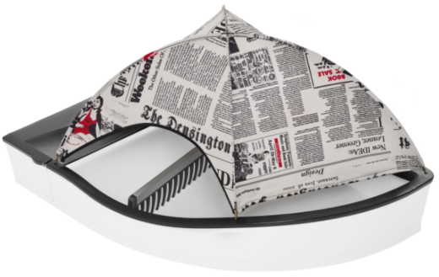
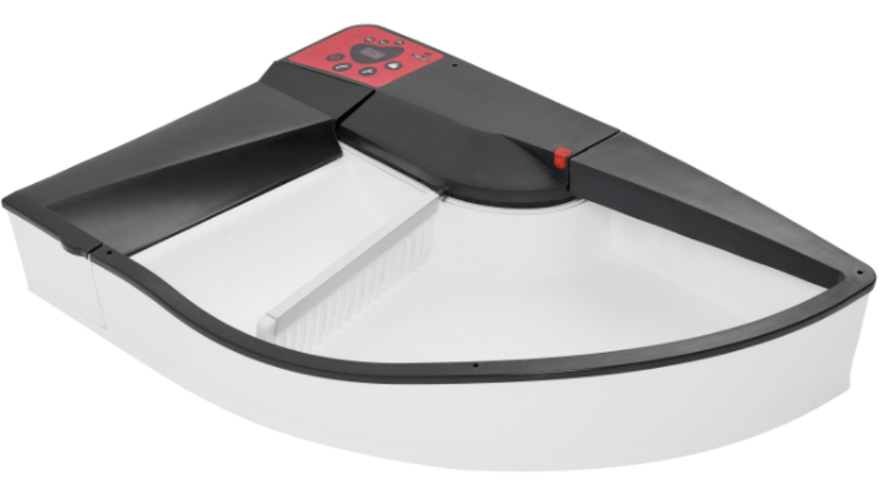
Product | Cat. | Price | Off | Client price | Qty | Value | Comments
Smart Kitty | ? | 140 | - | 140 | 1 | 140
Soft Tent | ?
Rakes | ? | - | - | - | 1 | - | Free
Panel | ? | - | - | - | 1 | - | Free
Additional Boxes (20 pcs ) |  | 10 | - | 10 | 1 | 10
Transport | EU | 25 |  | 25 | 1 | 25
Total |  |  |  |  |  |  | EUR (brutto)

Client Name and surname
Form of payment : | Prepayment | status:
Date of delivery: | 20.05.2017
Data for payment | QNC Andrzej Stasz  Paypal account: piotr@mspnet.eu  Title: Smart Kitty Order no …./2017
Account Number
Serial Number (S/N)
Adress e –mail
Delivery adress | Please fill it
Telephone number

If you want just fill “1” you want just fill „1”
SMART KITTY
White&Black |  |  |  | ? |  | White |  |  |  |  |  | ? |  |  |  | Black |  |  |  |  | ? |  |  | Black&White |  |  |  |  |  |  | ?
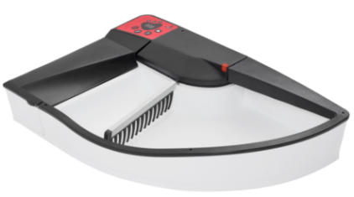 |  |  |  |  |  | 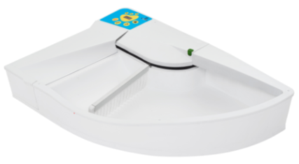 |  |  |  |  |  |  |  |  |  | 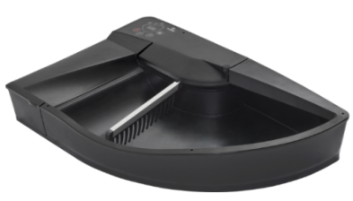 |  |  |  |  |  |  |  | 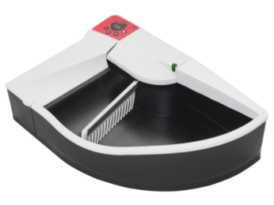
140 EUR |  |  |  |  |  | 140 EUR |  |  |  |  |  |  |  |  |  | 140 EUR |  |  |  |  |  |  |  | 140 EUR
RAKES 18&16
Black |  |  |  |  | ? | White |  |  |  |  | ? |  |  |  |  | Red |  |  |  |  |  | ? |  | Green |  |  |  |  |  | ?
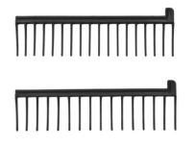 |  |  |  |  |  |  |  |  |  |  |  |  |  |  |  | 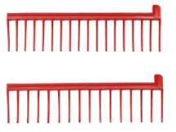 |  |  |  |  |  |  |  | 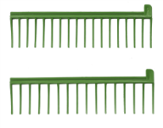
Panels
Black | ? |  | Red |  |  |  |  |  | ? | Blue |  |  | ? |  |  |  | Pink | ? |  |  |  |  | Green |  |  |  |  | ? | Grey |  |  |  | ?
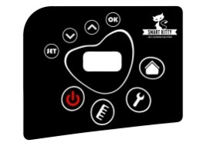 |  |  | 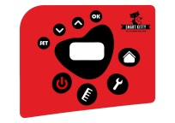 |  |  |  |  |  |  | 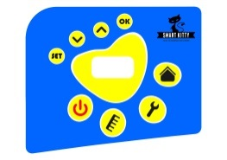 |  |  |  |  |  |  | 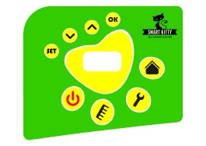  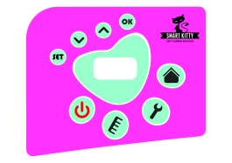 |  |  |  |  |  | 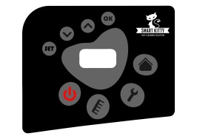
Soft Tent
Newspaper |  | ? | Zebra |  |  |  |  | ? |  | Blue |  |  |  |  | ? |  | Red |  |  | ? |  |  | Black |  | ? |  |  |  | Dots white |  |  |  |  |  | ?
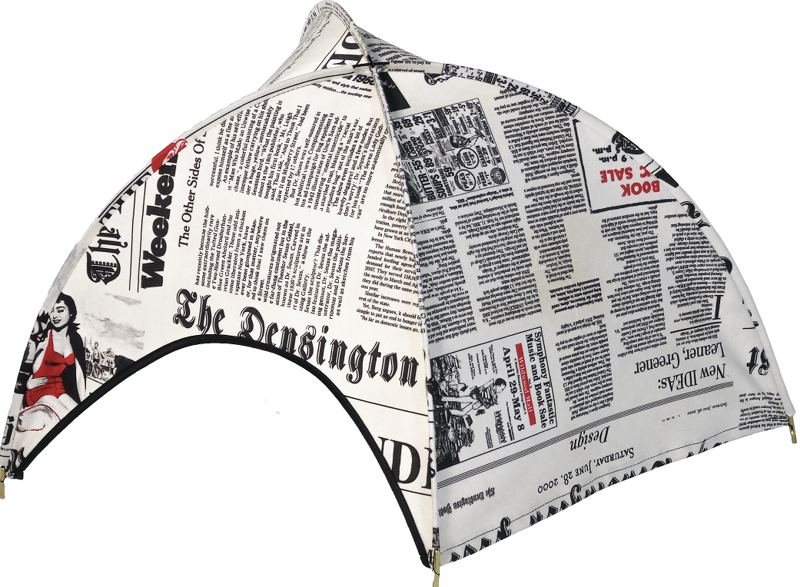 |  |  | 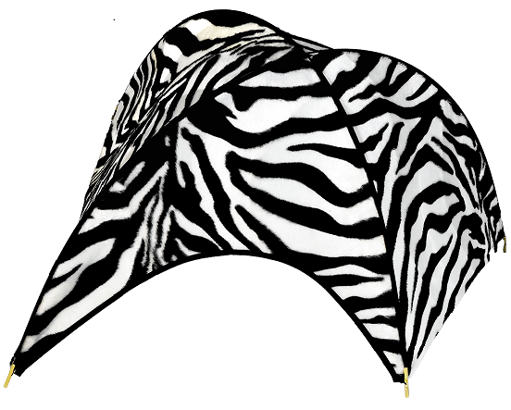 |  |  |  |  |  |  | 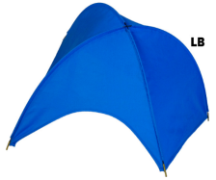 |  |  |  |  |  |  | 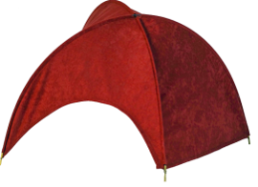
 |  |  |  |  |  |  |  |  |  |  |  |  |  |  |  |  |  |  |  |  |  |  | Grey |  |  |  | ? |  | Dots black |  |  |  |  | ?
 |  |  |  |  |  |  |  |  |  |  |  |  |  |  |  |  |  |  |  |  |  |  |  |  |  |  |  |  | 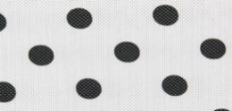
40 EUR |  |  | 35 EUR |  |  |  |  |  |  | 30 EUR |  |  |  |  |  |  | 25 EUR |  |  |  |  |  | 25 EUR |  |  |  |  |  | 35 EUR
Ocelot |  | ? | CatPaws |  |  |  | ? |  |  | Flowers 1 |  |  |  | ? |  |  | Rings |  | ? |  |  |  | Flowers 2 |  |  | ? |  |  | Boxes |  |  | ?
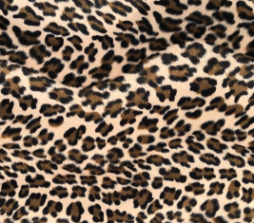 |  |  | 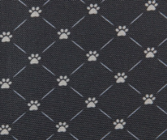 |  |  |  |  |  |  |  |  |  |  |  |  |  | 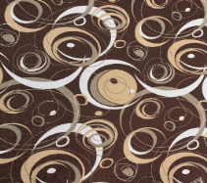 |  |  |  |  |  |  |  |  |  |  |  | 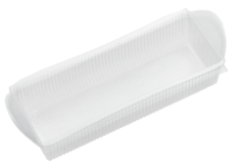
35 EUR |  |  | 35 EUR |  |  |  |  |  |  | 35 EUR |  |  |  |  |  |  | 35 EUR |  |  |  |  |  | 35 EUR |  |  |  |  |  | 10 EUR – 20 PCS

